פרולוג 3

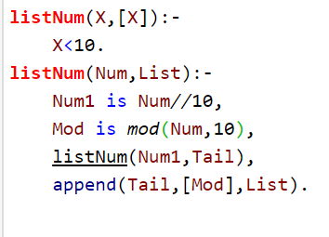

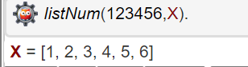2. א.

listNum(X,[X]):-

X<10.

listNum(Num,List):-

Num1 is Num//10,

Mod is mod(Num,10),

listNum(Num1,Tail),

append(Tail,[Mod],List).

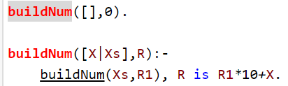2. ב.

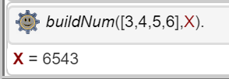

buildNum([],0).

buildNum([X|Xs],R):-

buildNum(Xs,R1), R is R1\*10+X.

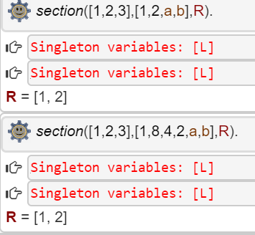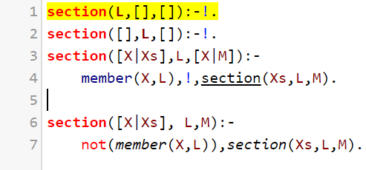3. א.

ב.